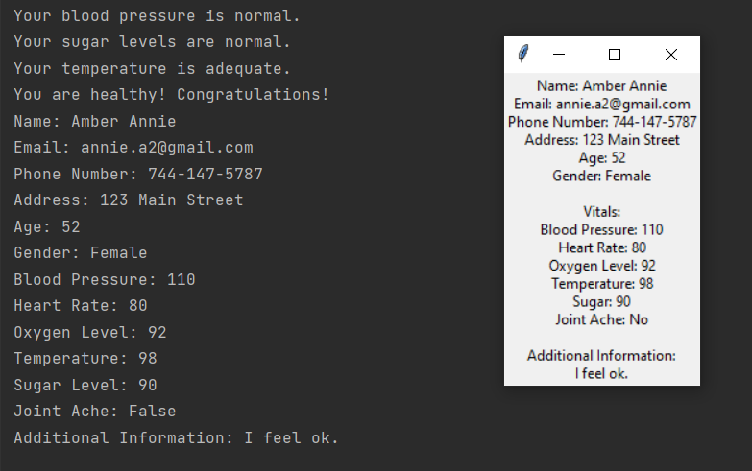

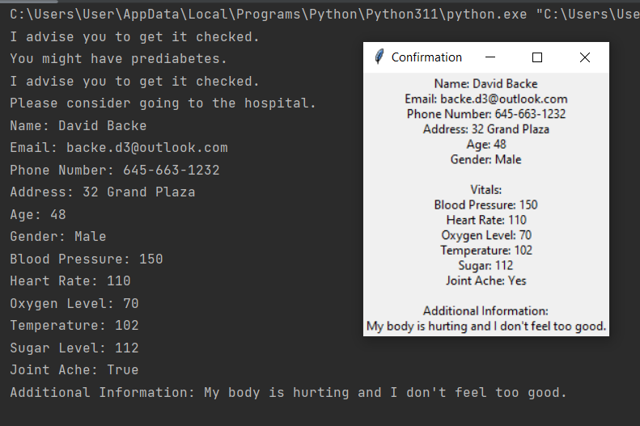

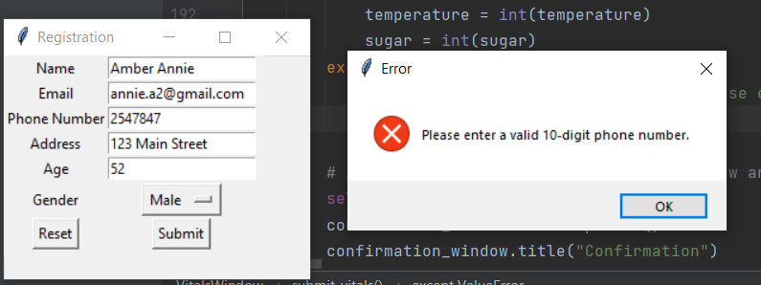

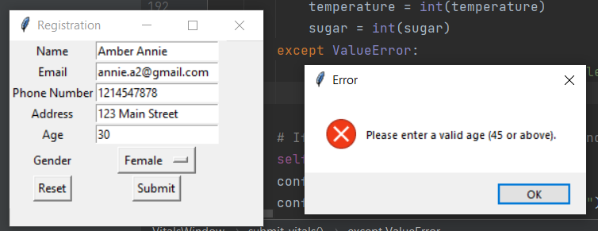

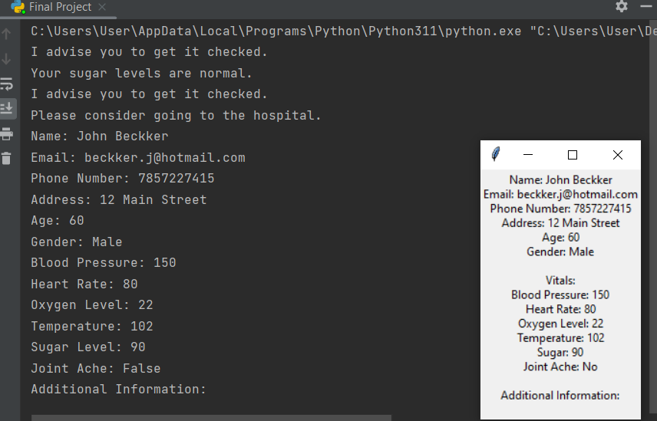

I had to fix a lot of thing. First, the statements wouldn’t show up because my data was in str instead of int.

I had to delete a lot of the code for data type validation because the phone numbers wouldn’t go through. I tried to check and understand what was going wrong but couldn’t so I had to delete it.

I previously had a better window opening, with better values and colours but some problem seemed to come in at every turn, which is why I had to remove and edit a lot of that code.

I tried modular approach differently, where I made 3 different windows, the MainWindow, the RegistrationWindow and the VitalsWindow. It didn’t work, even though I wrote the import code for each window in the main window. It led me to change basically 70% of my code since I had put MainWindow as the parent module which led to a lot of errors in the registration and vitals window.

The images did not work, despite making sure that the location was correct as well as the code. I don’t understand where it went wrong.